Upgrade your website to remove Wix adsUpgrade Now
Skip to Main Content


Home

About Us

Services

Why Preferred

Contact

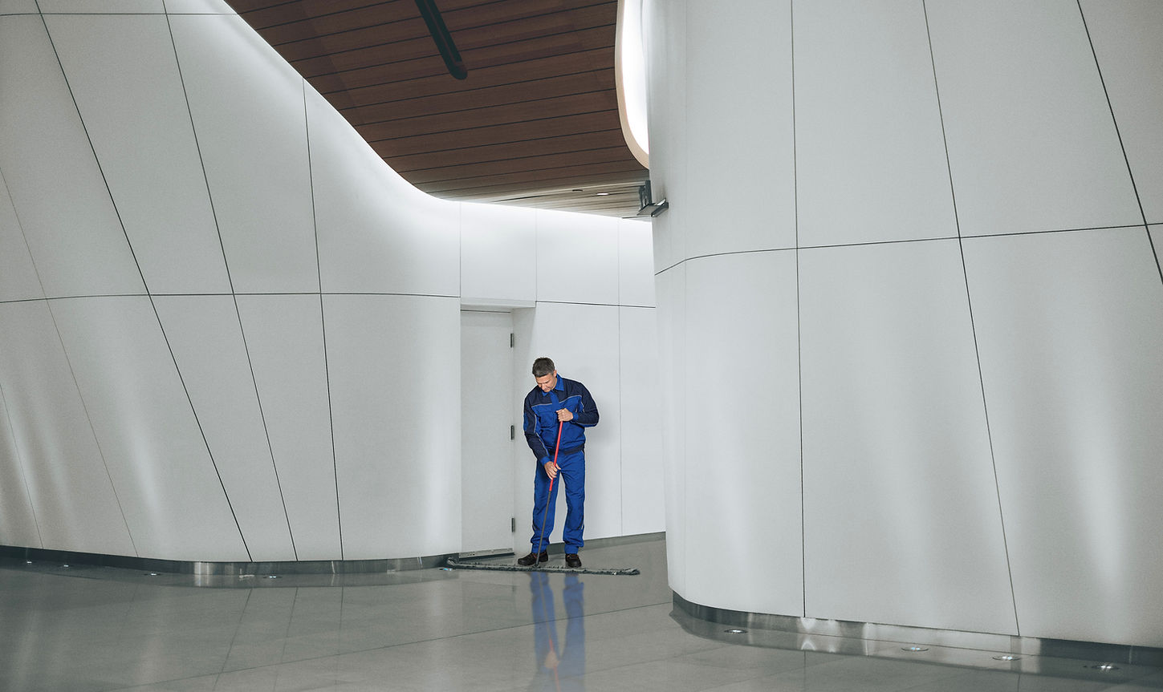
RELIABLE COMMERCIAL CLEANING
Create a clean, healthy work environment tailored for your needs.
Book a Consultation
At Preferred Maintenance, we take particular pride in our management, supervisory and trained technical staff. What more can be said about a company that still provides cleaning and maintenance services for several prominent medical facilities and other top industries.
35+
Trusted Years
150
Satisfied Customers
100+
Staff Members
200
Clean Spaces
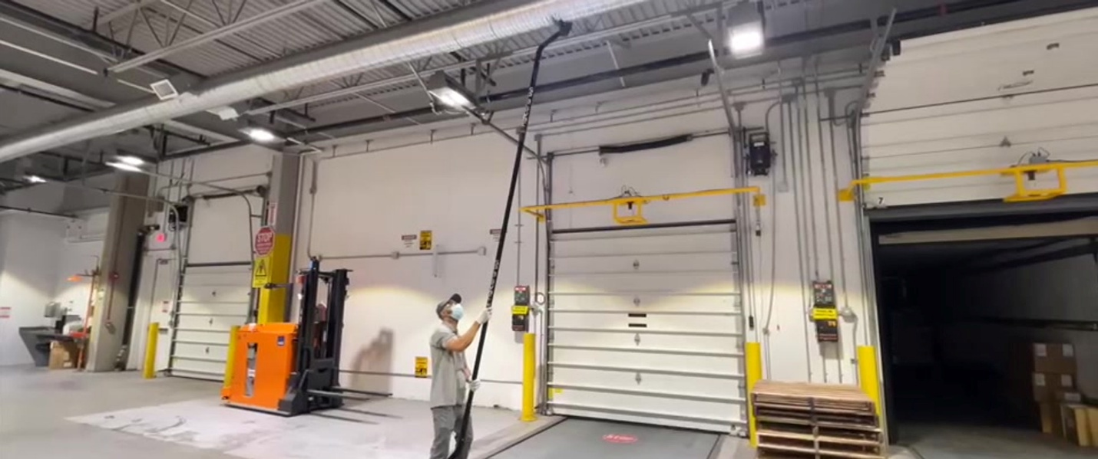
Play Video
WE WORK WITH ALL TYPES OF WORKPLACES
More Details
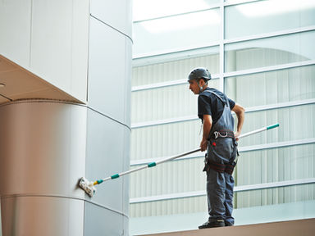
Corporate

Education
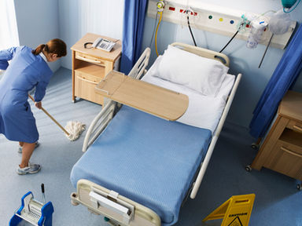
Medical
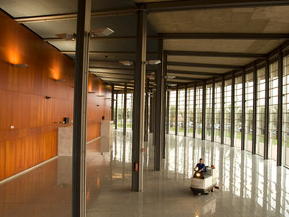
Hospitality
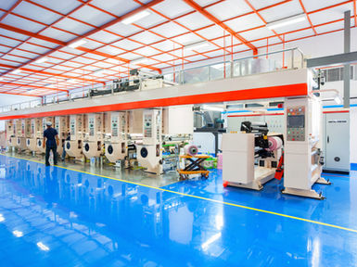
Manufacturing
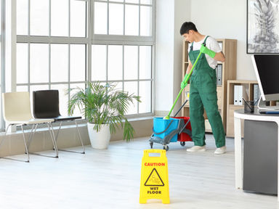
Office Spaces
CERTIFICATIONS
Experienced Providers
Professionally skilled team leaders and supervisors constantly monitor and inspect the work to ensure quality results for quality control.
Customized Schedules
We offer flexible cleaning schedules that can be tailored to your company's specific need.
Advanced Products
At Preferred Maintenance we strive to use the most up to date and technology advanced equipment and cleaning products on the market.
Extra Care Hygiene
We know that in today's world it is very important to keep the work environment super clean for everyone's personal hygiene and safety.
OUR REPUTATION IS IMMACULATE
I must share with you that 100% of the patients or family members comment on the cleanliness of the environment and how well it is maintained. It is comforting to patients to be in a clean facility because it is an outward sign of other activities that go on in the clinical area. I would appreciate it if you would communicate this to your staff and express our appreciation for a job well done.
Kim S, Administrator
Ridgefield Surgical Center
John values his clients and therefore sets and maintains high standards and expectations of his staff. We are very pleased with the high quality of services provided by Mr. Pereira and his staff and with their level of commitment. We find the staff to be professional, reliable, and trustworthy. It is a pleasure to recommend Preferred Maintenance without reservation as a professional and reputable cleaning service.
Alice H.
Advanced DermCare, P.C
Since contracting with Preferred Maintenance for approximately 4 years, I have been very pleased with their service. Their reliability and attention to detail is a welcome change from other services I have dealt with. Their cooperation with changing requirements and response to special requests has been very helpful.
Peter F.
Branson Ultrasonics Corp
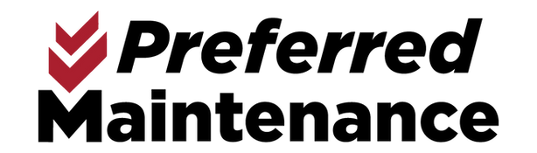
Danbury, Connecticut 06811
Phone: 203-743-2440
Fax: 203-743-0281
john@prefmaint.com
Book a Consultation
- Home
- About Us
- Services

- Why Preferred
- Contact
203-743-2440
john@prefmaint.com
© 2021 by Preferred Maintenance Inc. Proudly designed and built by: MRZ Designs

Upgrade your website to remove Wix adsUpgrade Now
Skip to Main Content


Home

About Us

Services

Why Preferred

Contact

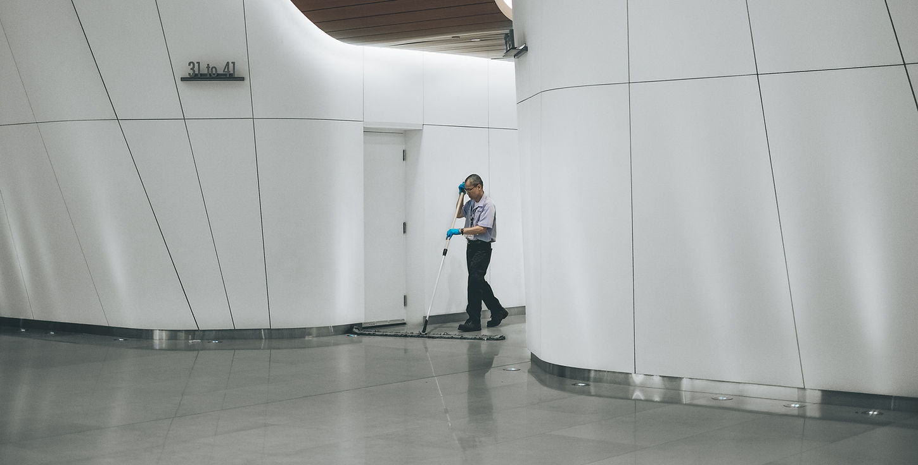
35+ YEARS OF TRUSTED CLEANING
At Preferred Maintenance, we take particular pride in our management, supervisory and trained technical staff. What more can be said about a company that still provides cleaning and maintenance services for several prominent medical facilities and other top industries. For over 35 years, our mission has been to offer the most effective combination of people, equipment and materials at a reasonable cost. We guarantee that these same goals will continue to be part of our philosophy and principles for the next 35 years.

LET US DO THE WORK
At Preferred Maintenance, we take pride in our management, supervisory, and trained technical staff. For 35 years our mission has been to offer the most effective combination of people and materials possible. Our staff is trained to provide a high level of reliable, cost-effective service that is tailored to each client’s particular needs.
​
Professionally skilled team leaders and supervisors constantly monitor and inspect the work to ensure quality results for quality control.

Small and large office buildings, industrial complexes, medical facilities, banks, educational facilities, and corporate headquarters are among the many accounts we serve.

Trusted service to our clients by skilled technicians is our guarantee of providing top quality performance to our ever-growing list of satisfied clients. These also include Fortune 500 companies, multi-tenant office buildings, manufacturing facilities, clean-room facilities and schools.

“You can trust what we do and we are proud of the word trust.”
OUR REPUTATION IS IMMACULATE
For our post construction projects at Danbury Hospital Preferred Maintenance has been performing all of our cleaning services. I have found them to perform outstanding work and are very flexible in meeting our deadlines.
John S.
Danbury Hospital
Preferred Maintenance has been servicing this manufacturing facility for nearly three years. I would have to say that John and his company are the best cleaning service in my 20 years at Eaton. I never have to ask them to clean this or you missed that. They always stay ahead and do the extra without being asked.
Eaton Aerospace
Preferred Maintenance has been servicing the daily cleaning needs at our Danbury facility for three years. During this time, MR. Pereira has been responsive to our needs and requests, often requiring his personnel to go above and beyond normal cleaning activities. No request has been too large or too small for Mr. Pereira’s immediate attention. Customer satisfaction is an apparent number one priority.
Ken S.
Mannkind Corp
The News-Times is using Preferred Maintenance for all of our cleaning needs at our Main Street Danbury Office and Plant location. Since they have been employed, they have been a pleasure to work with. John is as professional as they come, and his customer service skills are top rate. The plant area is filled with paper dust, ink drippings and spills. But is seems as if no job is too big for the crew at Preferred. We are so happy with our decision to go with Preferred. They do top quality work, have great customer service skills, and all at a reasonable price.
John C.
The News-Times
I was so pleased when you were able to continue our service here in New Milford. The service you and your people provide would be difficult to replace. It is so hard to find people who provide services you can count on. The quality of work you and your staff give us is of the highest standard.
Bonnie I.
Scientech
Preferred Maintenance was contracted to provide cleaning services for our Facility in Brookfield, CT. We are very pleased with the quality of their services. They are very professional, reliable and trustworthy.
Maria H.
STP Products Inc

Danbury, Connecticut 06811
Phone: 203-743-2440
Fax: 203-743-0281
john@prefmaint.com
Book a Consultation
- Home
- About Us
- Services

- Why Preferred
- Contact
203-743-2440
john@prefmaint.com
© 2021 by Preferred Maintenance Inc. Proudly designed and built by: MRZ Designs

Upgrade your website to remove Wix adsUpgrade Now
Skip to Main Content


Home

About Us

Services

Why Preferred

Contact

Services
Professional cleaning services for your industrial, commercial & institutional needs
​
Without obligation, we would welcome the opportunity to survey your cleaning and maintenance requirements and to submit a proposal for our professional services. Our past performance and expertise us a matter of record. Allow us to furnish you with a specific list of references to qualify our reputation and reliability.
​
Small and large office buildings, industrial complexes, medical facilities, banks and corporate headquarters are among the many accounts we serve. Trusted service to our clients by skilled technicians is our guarantee of providing top quality performance to our ever growing list of satisfied clients.
​
Preferred Maintenance, Inc is a total service contractor offering virtually any cleaning and maintenance service.
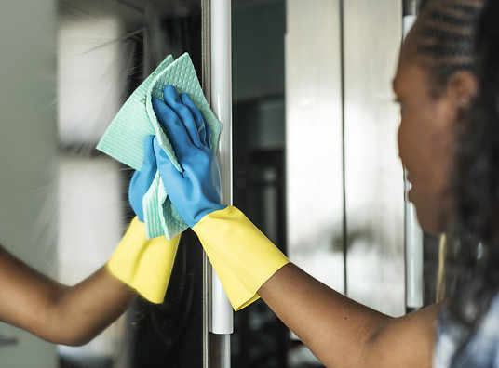
General Cleaning
Cleaning your space to get rid of dust and any filth for a clean environment.
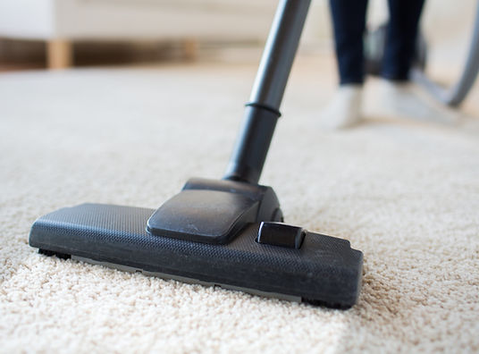
Carpet cleaning
You can trust us to get your carpets clean every time, no matter the condition.
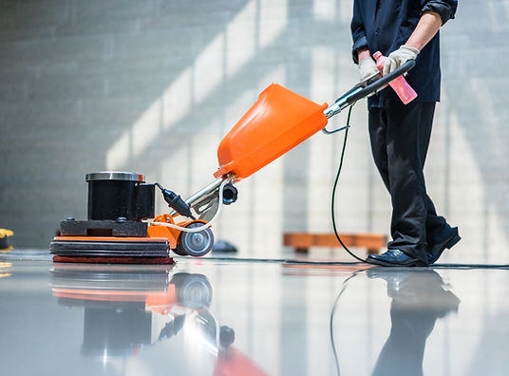
Floor Cleaning
From tile floor to marble, concrete, vinyl and everything in between we can clean it and have them shining like new.

Upholstery
Furniture can get dirty easily and feeling not so new, we can bring new life to your furniture

Clean Rooms and Surgery
Medical rooms needs to be a super clean environment to operate everyday, let us take care of that for you.

Restroom Sanitization
Restrooms can feel dirty easily with heavy traffic, let us clean your restrooms and have them feeling bright and shiny.

Lightning Maintenance
We can take care our the lighting in your building and replace lights and make sure everything is working properly.

Construction and Preoccupancy
We will taker that finished construction site and get it ready for new life by cleaning every surface and have it ready to be occupied.

Windows and Glass
Windows let in life to a space but can fog up quickly, let us keep those shining and glimmering.
Get a Quote
We welcome the opportunity to serve you with any of your cleaning and maintenance requirements.
Please feel free to give us a call or complete the form below.

First Name
Last Name
Email
Send


Danbury, Connecticut 06811
Phone: 203-743-2440
Fax: 203-743-0281
john@prefmaint.com
Book a Consultation
- Home
- About Us
- Services

- Why Preferred
- Contact
203-743-2440
john@prefmaint.com
© 2021 by Preferred Maintenance Inc. Proudly designed and built by: MRZ Designs

Upgrade your website to remove Wix adsUpgrade Now
Skip to Main Content


Home

About Us

Services

Why Preferred

Contact


CUSTOM CLEANING AT YOUR SERVICE
As a proactive company, Preferred Maintenance has taken the opportunity to participate in the ISSA’s “Cleaning Industry Management Standard – Green Building” in order to develop and implement a complete green-cleaning program as well as maintain a sustainable operation. We assure that the most effective, environmentally safe products are at our disposal for both employees and customers.
Book a Consultation
WE USE THE BEST PRODUCTS
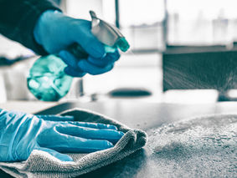
Microfibre Cloths
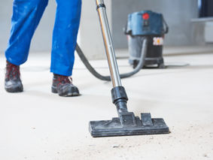
Industrial Vacuums
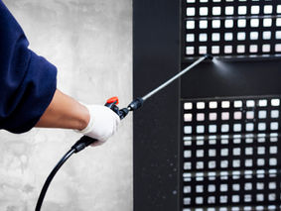
Disinfectants
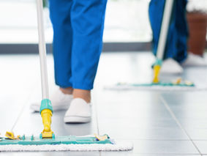
Flat Mops
WE GIVE EXTRA CARE
Windows
Hard Floors
Carpets
Fabric
For over 35 years, our mission has been to offer the most effective combination of people and materials possible. Our staff is trained to provide a high level of reliable, cost effective service that is tailored to each client’s particular needs.
Our Professionally skilled team leaders and supervisors constantly monitor and inspect their work to insure quality results for quality control.

Each supervisor is equipped with a smartphone or tablet to help monitor the quality of work that is being provided. Our regularly scheduled walk throughs give us a unique quality report analysis for every client and a review of every walk through is immediately emailed to the client.

Play Video

Danbury, Connecticut 06811
Phone: 203-743-2440
Fax: 203-743-0281
john@prefmaint.com
Book a Consultation
- Home
- About Us
- Services

- Why Preferred
- Contact
203-743-2440
john@prefmaint.com
© 2021 by Preferred Maintenance Inc. Proudly designed and built by: MRZ Designs

Upgrade your website to remove Wix adsUpgrade Now
Skip to Main Content


Home

About Us

Services

Why Preferred

Contact


CONTACT PREFERRED
FOR MORE INFORMATION
ON OUR CLEANING SERVICES

GET YOUR FREE QUOTE TODAY!

First Name
Last Name
Email
Company
Subject
Address
Phone
Leave us a message...
Submit


Danbury, Connecticut 06811
Phone: 203-743-2440
Fax: 203-743-0281
john@prefmaint.com
Book a Consultation
- Home
- About Us
- Services

- Why Preferred
- Contact
203-743-2440
john@prefmaint.com
© 2021 by Preferred Maintenance Inc.

